Sample Neighborhood Outreach Letter – Please Personalize as You See Fit
Date

Dear Neighbor,
I am your neighbor at insert address. I am volunteering as a Neighborhood Contact for the Banner Mountain Firewise Community. Firewise Communities are collections of neighbors who share wildfire preparedness information and encourage defensible space, home hardening, and safe evacuation practices.
To start, I am gathering contact information for our immediate neighbors. This will generate our neighborhood contact list which I will use to share information between the Banner Mountain Firewise Community and our neighborhood. Please be assured that your contact information is just for our small network.
Our network would serve as a grass roots information system with shared email addresses and phone numbers, and if needed, 2-way radios, to pass on updates, worthy news, and, on occasion, requests for assistance. Our intent is that we support each other during threats of wildfires, snowstorms, power/phone outages, etc. Other Banner Mountain neighborhoods have such networks in place and they are functioning well.
The Banner Mountain Firewise Community, which covers about 1500 properties, is fully active in the Nevada County, State and Federal Firewise hierarchy. Our Banner Mountain Firewise leadership, led by Jeff Peach, is engaged with County emergency workers.
Information about wildfire and other emergencies is available to you on the Banner Mountain website at www.bannermountain.org. You can visit this website to learn the status of evacuation planning, property fire insurance, home “hardening” recommendations, and more.
Further, if you are not an FBM member, do take that important step via the website.
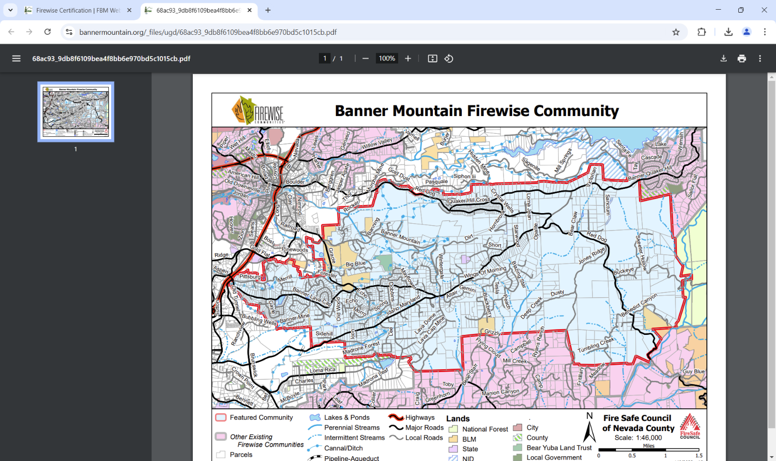
Best wishes!

Your Neighbor,

Signed
Name
Address
Contact Information

